Practical Skill 1: Reading Error Messages

Broken Code Example: SyntaxError

Broken code – missing closing brace
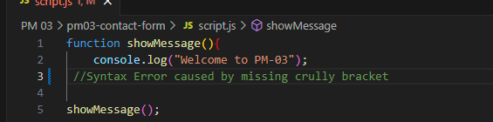
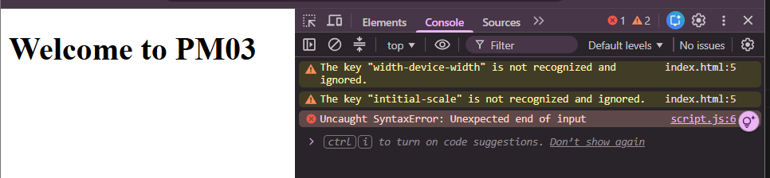

Broken Code Example: ReferenceError

Broken code: Wrong variable name
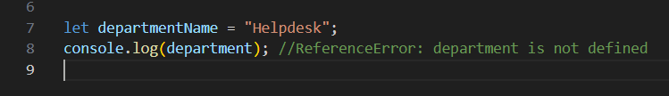
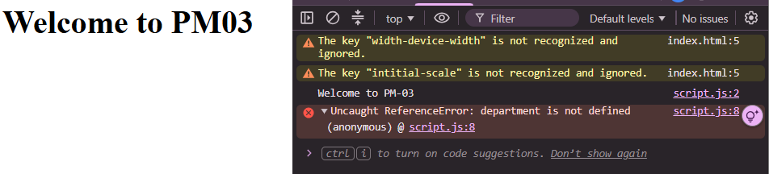

Practical Skill 4: DOM Manipulation

Reading input values
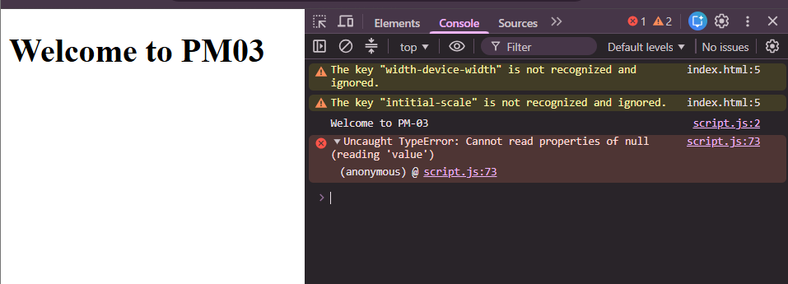

Adding Elements Dynamically
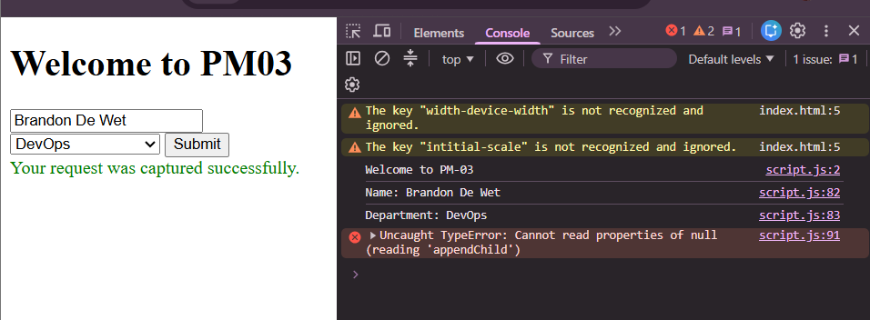

Practical Skill 5: Events

Input Event Example: Character Counter
